EXP. NO. 1

WEB PAGE CREATION USING HTML AND CSS WITH FRAMES, HOTSPOTS AND LINKS

AIM:
To create a web page that embeds a map with hotspots, frames, and links. The web page should be designed using HTML, incorporating embedded, external, and inline CSS for styling. This exercise aims to enhance understanding of integrating multimedia elements like maps, creating interactive hotspots, and organizing content using frames while applying different CSS techniques for styling.

ALGORITHM:

Create the HTML structure:
- Set up the basic HTML document with <!DOCTYPE html>, <html>, <head>, and
<body> tags.
- In the <head>, link the external CSS file (<link> tag), define the title, and include any metadata.
- In the <body>, create the necessary elements:
  - Frames: Use the <frameset> tag to create a frame layout (for older browsers, use <iframe> instead).
  - Map: Use the <img> tag to display a map.
  - Hotspots: Create clickable regions using the <map> and <area> tags.
  - Links: Add hyperlinks (<a>) to navigate to different parts of the page or external sites.

Create CSS Styles:
- External CSS: In a separate file, define styles such as colors, fonts, and layout for the entire page.
- Inline CSS: Use the style attribute within specific tags to apply styles (e.g., in <div> or <p> tags).
- Embedded CSS: Inside the <style> tag in the <head>, define styles for specific elements like the map, frames, and text.

Map with Hotspots:
- Use the <map> tag to create an image map.
Define the <area> tag for each hotspot, specifying the coordinates (e.g., coords="x,y,x2,y2") for clickable areas on the map
FRAMES:
- Use the <iframe> tag for embedding external content like a map or another webpage, with attributes such as src for the URL, width, and height.

Add Links:
- Inside the <body>, use the <a> tag to create links for navigation (for example, to link to specific parts of the page or external sites).

Test the Page:
- Test the webpage to check the functionality of frames, hotspots, and links. Ensure that the map hotspots are clickable and the linked content displays correctly.
- Ensure that the styles are applied properly using inline, embedded, and external CSS.
CODE:
index.html :
<!DOCTYPE html>
<html lang="en">
<head>
<meta charset="UTF-8">
<title>ProctorGate | Exam Registration Portal</title>
<link rel="stylesheet" href="style.css">
<style>
/* 1b. Internal CSS */
:root {
--primary-blue: #007bff;
--gradient-bg: linear-gradient(135deg, #00d2ff 0%, #3a7bd5 100%);
}
body {
font-family: 'Segoe UI', sans-serif;
margin: 0;
background: var(--gradient-bg); /* Gradient background like your image */
min-height: 100vh;
scroll-behavior: smooth;
}

header {
background: rgba(255, 255, 255, 0.1);
backdrop-filter: blur(10px);
padding: 15px 50px;
display: flex;
justify-content: space-between;
align-items: center;
position: sticky;
top: 0;
z-index: 1000;
}
.center-title {
position: absolute;
left: 50%;
transform: translateX(-50%);
color: white;
font-size: 1.4rem;
text-transform: uppercase;
}
.auth-buttons a {
color: white;
text-decoration: none;
padding: 10px 20px;
font-weight: bold;
}
/* 1a. Map & Frame Section */
#map-section {
padding: 40px;
text-align: center;
}

.map-frame {
border: 10px solid rgba(255,255,255,0.2);
border-radius: 20px;
overflow: hidden;
max-width: 800px;
margin: auto;
}
</style>
</head>
<body>
<header>
<div style="color: white; font-weight: bold; font-size: 1.2rem;">ProctorGate</div>
<h1 class="center-title">Registration Portal</h1>
<div class="auth-buttons">
<a href="#register">SIGN UP</a>
<a href="#login">LOGIN</a>
</div>
</header>
<section id="map-section">
<div class="map-frame">
<iframe src="https://www.google.com/maps/embed?pb=!1m18!1m12!1m3!1d4013074.4419099195!2d75.64742901087395!3d10.809932281385466!2m3!1f0!2f0!3f0!3m2!1i1024!2i768!4f13.1!3m3!1m2!1s0x3b00c582b1189633%3A0x559475cc463361f0!2sTamil%20Nadu!5e0!3m2!1sen!2sin!4v1770695126615!5m2!1sen!2sin" width="100%" height="300" style="border:0;" allowfullscreen="" loading="lazy"></iframe>
</div>
</section>

<section id="register" style="padding-bottom: 50px;">
<div class="reg-card">
<div class="close-btn">×</div>
<h2 class="form-title">• Registration Form •</h2>

<form id="regForm" onsubmit="return validateRegistration()">
<div class="input-group">
<input type="text" id="fName" required>
<label>First Name (Min 6 letters)</label>
</div>
<div class="input-group">
<input type="text" id="lName" required>
<label>Last Name</label>
</div>
<div class="input-group">
<textarea id="address" required></textarea>
<label>Residential Address</label>
</div>
<div class="input-group">
<input type="email" id="email" required>
<label>Email Address</label>
</div>
<div class="input-group">
<input type="password" id="pass" required>
<label>Password</label>
</div>
<div class="input-group">
<input type="text" id="mobile" required>
<label>Phone Number</label>
</div>

<div class="input-group">
<select id="examCenter">
<option value="" disabled selected></option>
<option value="Chennai">Chennai</option>
<option value="Bangalore">Bangalore</option>
</select>
<label>Exam Center</label>
</div>
<div class="input-group">
<select id="examSubject">
<option value="" disabled selected></option>
<option value="Math">Mathematics</option>
<option value="CS">Computer Science</option>
</select>
<label>Subject</label>
</div>
<div class="terms">
<input type="checkbox" id="terms">
<span>I agree to the terms and conditions.</span>
</div>
<button type="submit" style="margin-top:20px; width:100%; padding:12px; background:#00d2ff; border:none; color:white; border-radius:5px; font-weight:bold; cursor:pointer;">REGISTER</button>
</form>
</div>
</section>
<footer class="contact-footer">
<div class="footer-content">
<div class="contact-info">
<h4>Contact Us</h4>
<p>📍 123 Exam Portal Ave, Digital City</p>
<p>📞 +1 (555) 987-6543</p>
<p>✉️ info@proctorgate.com</p>
</div>
<div class="footer-links">
<h4>Quick Links</h4>
<a href="#map-section">Exam Centers</a><br>
<a href="#register">Register Now</a><br>
<a href="#">Privacy Policy</a>
</div>
</div>
<div class="copyright">
&copy; 2026 ProctorGate Online Exam Registration Portal. All Rights Reserved.
</div>
</footer>
<script src="script.js"></script>
</body>
</html>
style.css :
/* 1b. External CSS */
.reg-card {
background: white;
max-width: 450px;
margin: auto;
padding: 40px;
border-radius: 5px;
box-shadow: 0 10px 40px rgba(0,0,0,0.2);
position: relative;
}

.close-btn {
position: absolute;
right: 20px;
top: 15px;
color: #00d2ff;
font-size: 24px;
cursor: pointer;
}
.form-title {
color: #007bff;
text-align: center;
font-weight: 500;
margin-bottom: 40px;
}
/* Floating Label Animation & Underline Effect */
.input-group {
position: relative;
margin-bottom: 30px;
}
.input-group input,
.input-group textarea,
.input-group select {
width: 100%;
padding: 10px 0;
font-size: 16px;
border: none;
border-bottom: 2px solid #00d2ff;
outline: none;
background: transparent;
appearance: none; /* Removes default select arrow */
}

.input-group label {
position: absolute;
top: 0;
left: 0;
padding: 10px 0;
color: #999;
pointer-events: none;
transition: 0.3s;
}
/* Label moves up when focused or has content */
.input-group input:focus ~ label,
.input-group input:valid ~ label,
.input-group textarea:focus ~ label,
.input-group textarea:valid ~ label,
.input-group select:focus ~ label,
.input-group select:not(:placeholder-shown) ~ label {
top: -20px;
font-size: 12px;
color: #007bff;
}
.terms {
display: flex;
align-items: center;
gap: 10px;
font-size: 12px;
color: #666;
}

.contact-footer {
background: #0a2342; /* Deep navy for contrast */
color: white;
padding: 40px 20px 20px 20px;
margin-top: 50px;
}

.footer-content {
display: flex;
justify-content: space-around;
flex-wrap: wrap;
max-width: 1000px;
margin: auto;
text-align: left;
}
.contact-info h4, .footer-links h4 {
color: #00d2ff;
border-bottom: 2px solid #00d2ff;
display: inline-block;
margin-bottom: 15px;
}
.footer-links a {
color: #ccc;
text-decoration: none;
line-height: 1.8;
transition: 0.3s;
}
.footer-links a:hover {
color: #fff;
}

.copyright {
text-align: center;
margin-top: 30px;

padding-top: 20px;
border-top: 1px solid rgba(255,255,255,0.1);
font-size: 0.8rem;
color: #888;
}

OUTPUT:
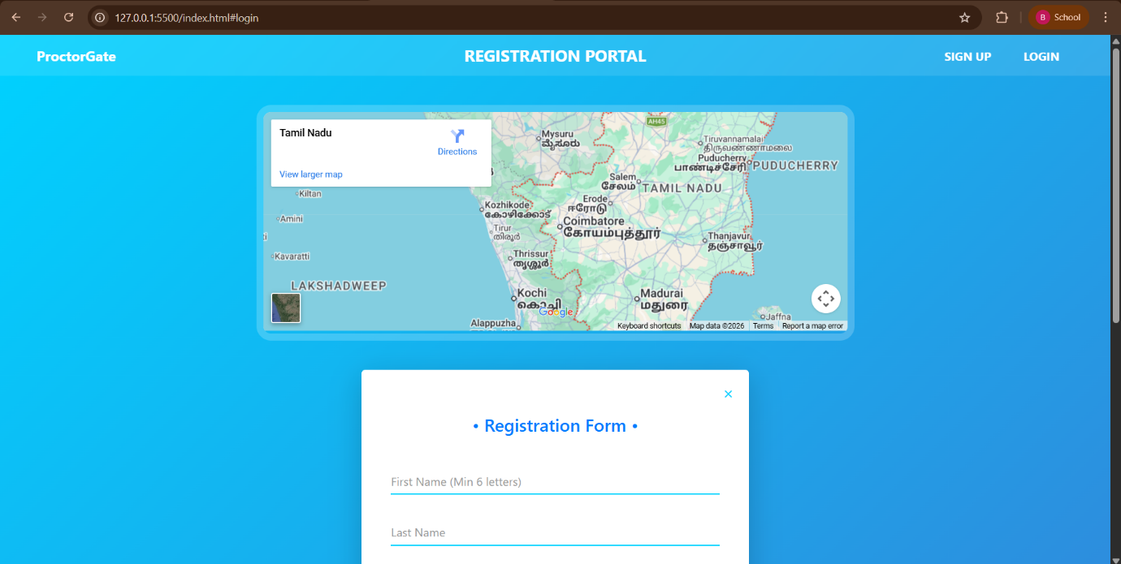

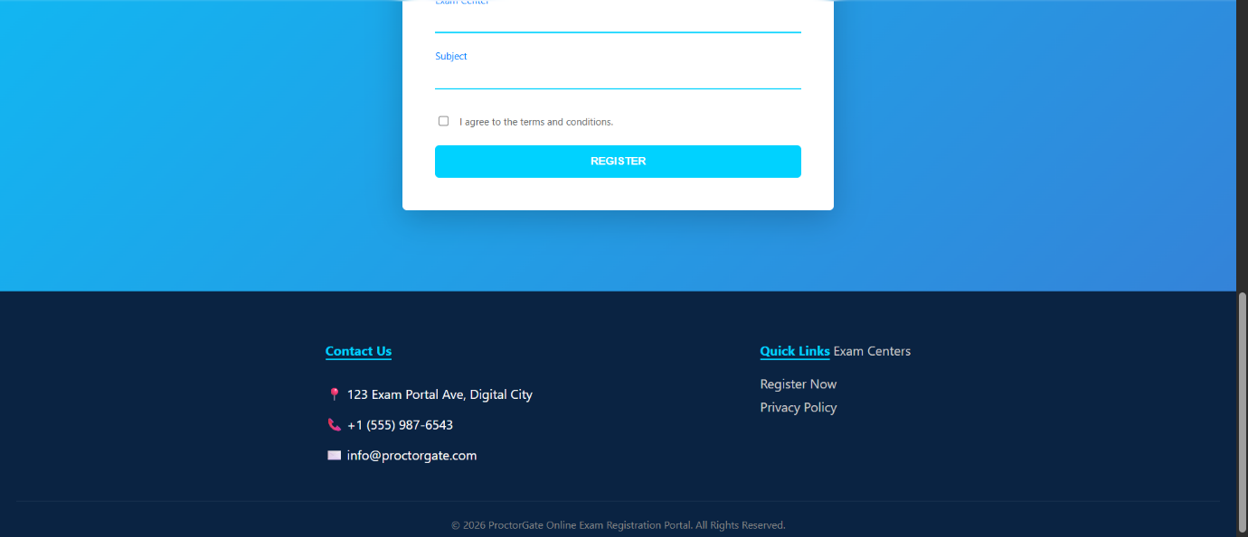
RESULT:
Html Page is created with embedded map along with hot spot, frames &
links.

